WHAT’S THE DIFFERENCE? Pastor John Fanous
The Story of the Protestant Reformation Edgewater Covenant Church
January 3, 2010

THE STORY OF THE
PROTESTANT REFORMATION

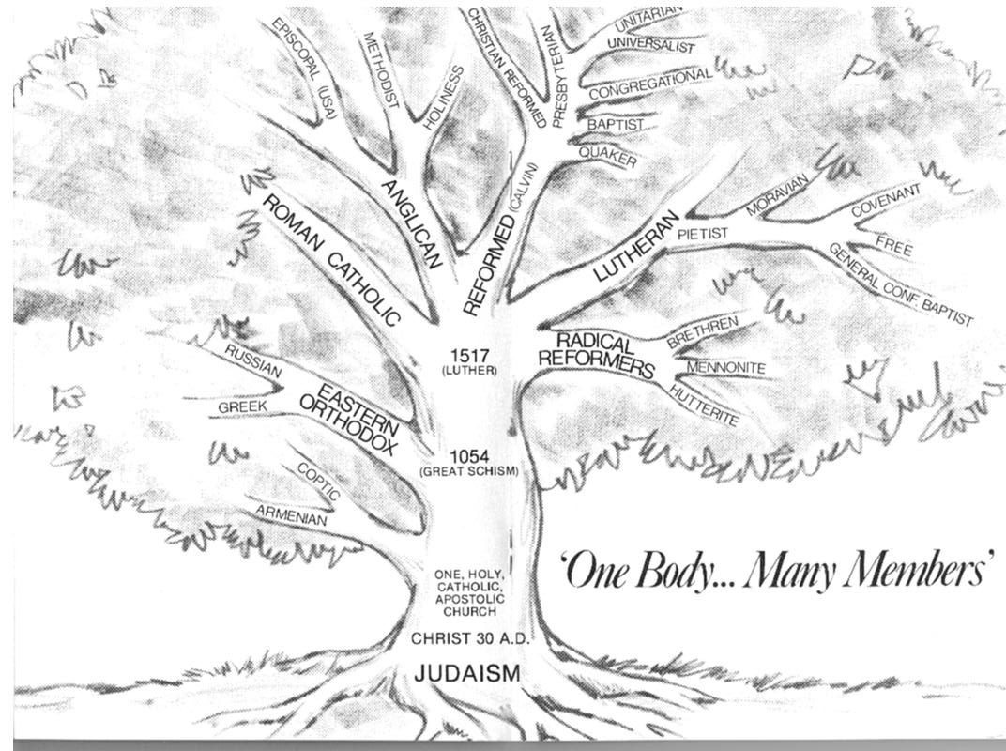

MARTIN LUTHER (1483-1546), German, died at age of 62

Luther nearly died in a thunderstorm in 1505, became a monk in 1506, a Catholic priest in 1507, earned a Doctor of Theology degree and became a professor and chair of Biblical studies at Wittenberg University in 1512.

- Visited Rome in 1510-1511
- Taught classes on Psalms, Romans, and Galatians from 1513-1517
- Responded to John Tetzel selling “indulgences” in 1517

- In 1517, Luther posted “95 Theses” for debate on the door of the Castle church

Wrote several articles:
- The Bible has authority over the Pope and church leaders
- Jesus saves people through His righteousness, not through our works
- The fruit of faith in Jesus is good works
- The community of believers in Jesus are priests

The Catholic Church reacts: sends Luther an order to retract his statements and burn his writings. Luther’s response: _________________

In 1521, he is excommunicated and put on trial

Luther is “kidnapped” and does something amazing:

Violence breaks out, and in 1522, Luther is allowed to return to Wittenberg University to bring peace. Peasants War.

Other things Luther did:
- Encouraged churches to use people’s language
- Started Christian schools
- Wrote hymns, including “A Mighty Fortress is Our God”

WHAT ARE THE DIFFERENCES?

1. THE BIBLE IS THE ______________________________ FOR OUR FAITH
sola Scriptura

“All Scripture is God-breathed and is useful for teaching, rebuking, correcting and training in righteousness, so that the man of God may be thoroughly equipped for every good work.” 2 Timothy 3:16–17

2. WE ARE SAVED BY _________________________
sola gratis, sola fide

“For it is by grace you have been saved, through faith—and this not from yourselves, it is the gift of God— not by works, so that no one can boast.” Ephesians 2:8–9

3. JESUS IS THE ONLY “______________________” BETWEEN GOD AND OURSELVES
solus Christus

“For there is one God and one mediator between God and men, the man Christ Jesus.” 1 Timothy 2:5

4. SOME OTHER DIFFERENCES:

No ___________________ (never mentioned in Bible)

The number of _____________________ (Matthew 28:19, Luke 22:19)

Priests and pastors can _______________! (1 Corinthians 9:5)

WHAT SHOULD OUR POSTURE BE TOWARD CATHOLICS?

“But in your hearts set apart Christ as Lord. Always be prepared to give an answer to everyone who asks you to give the reason for the hope that you have. But do this with gentleness and respect, keeping a clear conscience, so that those who speak maliciously against your good behavior in Christ may be ashamed of their slander. ” 1 Peter 3:15–17a

1. SHOW RESPECT BY BEING ___________________
Respect = “a high or special regard”

2. BUILD ON _______________________________

“And the Lord’s servant must not quarrel; instead, he must be kind to everyone, able to teach, not resentful.” 2 Timothy 2:24

3. NEVER ARGUE – ______________ AND _____________

4. GET RID OF ALL __________________________

